ManyChat to Mailchimp — Subscriber Synchronization Automation

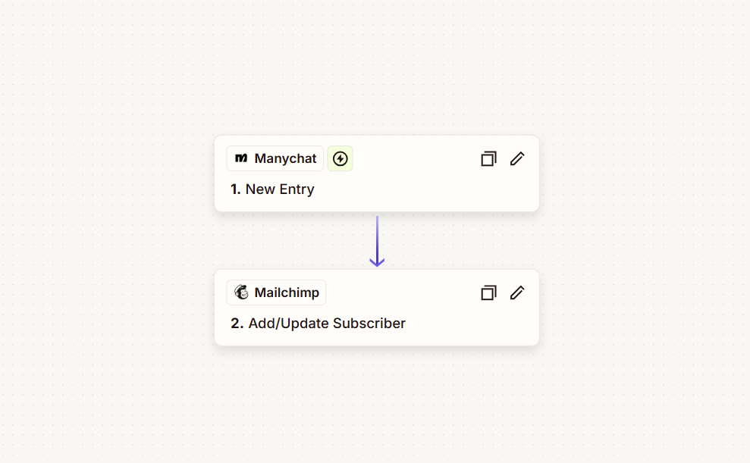

Project Description
A simple marketing automation that connects ManyChat with Mailchimp and keeps chatbot leads moving into the email marketing system automatically. Whenever a new ManyChat contact enters the workflow, their information is passed to Mailchimp, where the subscriber is either added to the audience or updated if they already exist. This type of ManyChat-to-Mailchimp connection is supported through Zapier.

Automation Scope
- ManyChat new-entry trigger
- Contact and subscriber data transfer
- ManyChat-to-Mailchimp integration
- Mailchimp audience synchronization
- New subscriber creation
- Existing subscriber updates
- Automated email-list management
- Lead data synchronization
- Reduced manual contact management

Workflow
ManyChat New Entry → Mailchimp Add/Update Subscriber
The automation starts when a new contact enters through ManyChat and sends the relevant subscriber information directly to the selected Mailchimp audience. Mailchimp’s Add/Update Subscriber action can create a new subscriber or update an existing record, helping keep the audience current as contacts move through the chatbot experience.

Key Objective
Keep ManyChat leads automatically connected to the email marketing system, so new contacts are added or updated in Mailchimp without manual data entry. This creates a cleaner handoff from chatbot conversations into ongoing email marketing and follow-up.

